AUTOMATA THEORY CAT 2
Name: Augustine Gitonga
Reg No: B135/31336/2024
Unit: Automata Theory
Date: 3/18/2026
Question 1
a) Definition) Automaton
An automaton is a machine that reads input symbols and changes states according to rules to decide whether to accept or reject a string.
ii) Alphabet
An alphabet is a finite set of symbols used to form strings.
Example: Σ = {0,1}
iii) Language
A language is a set of strings formed from an alphabet.
Example: L = {0, 11, 101}
b) Example of a finite set
{1, 2, 3, 4}
c) Mathematical Induction
Mathematical induction is a method of proving statements for all natural numbers by:
- Proving a base case
- Assuming true for n and proving for n+1
Question 2
a) Regular Expression
A regular expression is a way of describing patterns of strings.
b) Regular expression (only zeros)
c) Components of a Finite Automaton
- Set of states (Q)
- Alphabet (Σ)
- Transition function (δ)
- Start state (q₀)
- Accept states (F)
Question 3
a) DFA
A DFA is an automaton where each input leads to exactly one next state.
b) NFA
An NFA allows multiple possible next states for the same input.
c) Difference
DFA has one transition per input, while NFA can have many.
Question 4
Given: L = {aⁿbⁿcⁿ, n ≥ 1}
a) Explanation
A PDA uses one stack and can only match two groups (like aⁿbⁿ).
The language aⁿbⁿcⁿ needs three equal parts.
An LBA can handle this because it uses tape memory and can compare all symbols.
b) LBA working
- Mark one ‘a’
- Match with one ‘b’
- Match with one ‘c’
- Repeat
If all match accept
If not reject
c) Memory difference
- LBA: limited memory
- Turing Machine: unlimited memory
Question 5
Given: L = {aⁿbⁿ, n ≥
- PDA State Diagram
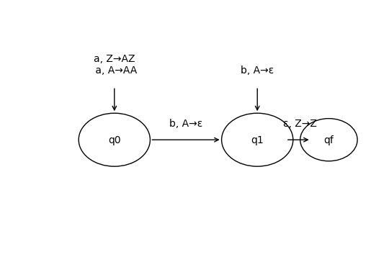
Explanation of Diagram
- q0: Read ‘a’, push A into stack
- Move to q1 when ‘b’ starts
- In q1: pop A for each ‘b’
- If stack returns to Z → accept

b) Stack behavior aaabbb
Step | Stack
Start | Z
a | AZ
a | AAZ
a | AAAZ
b | AAZ
b | AZ
b | Z
Final → Accepted

c) Finite automata fail for languages that require counting or matching.
- It cannot remember unlimited information
- It cannot count beyond a certain limit
- It has no extra memory like a stack or tape

Practical application examples
1.Password pattern checking
A system checking if a password:
- starts with a letter
- followed by numbers
Example: A123, B456
- It only checks a fixed pattern
- No need to count or remember long history
2. Vending machine states
- moves between states (e.g., 0 shillings, 10, 20, 30…)
- gives an item when enough money is inserted
finite automaton because:
- It uses limited states
- Does not need to remember un

